Alarm Agent Antenna/Cable Guide for Upgrades

- First Identify your Alarm Agent Model. Alarm Agent outdoor enclosure or Alarm Agent indoor enclosure. See picture below:

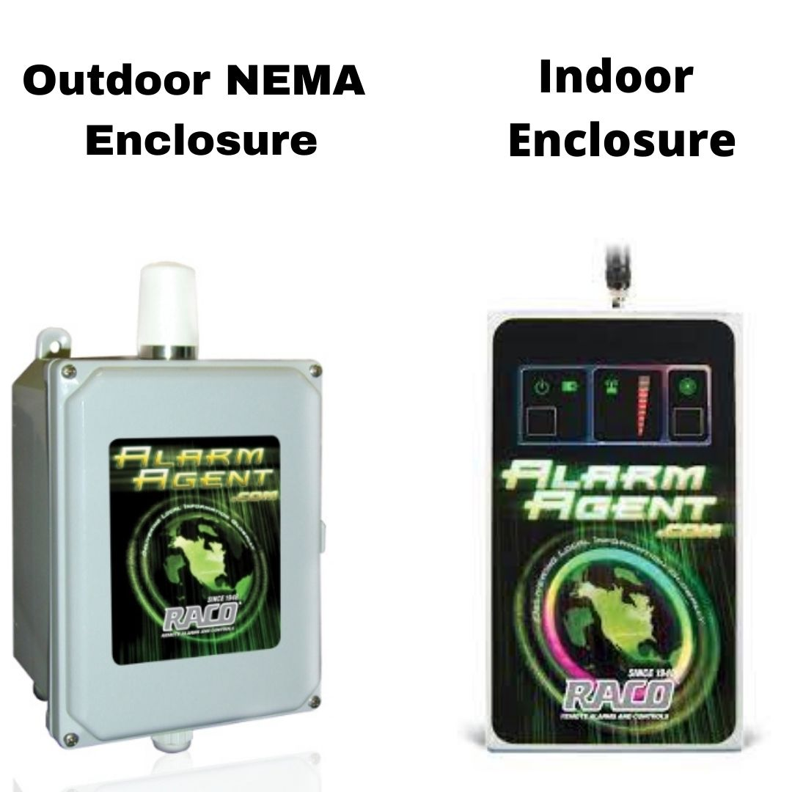

For Base Models with no Extension Cable below are the needed antennas for upgrades along with the Board/Radio assembly.

For the Alarm Agent outdoor enclosure base model. All that is needed is the LTE RM3 SMA (Male) antenna. See picture below: Part # 822AA-DigitalRM3S

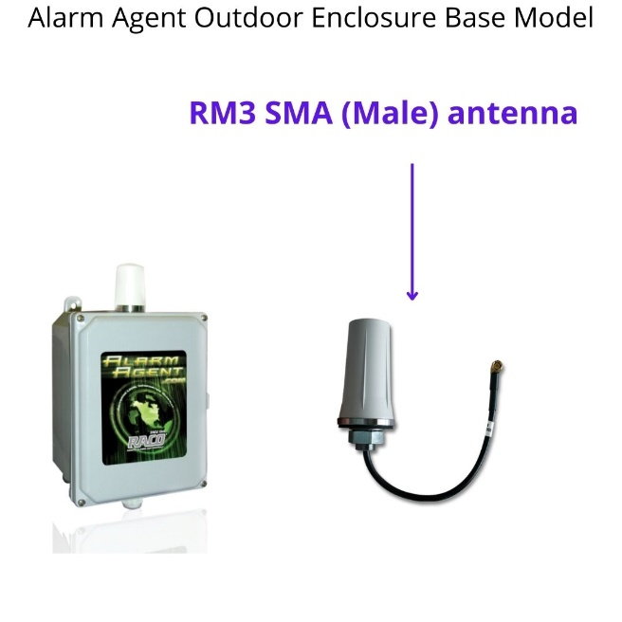

For the Alarm Agent indoor enclosure base model. All that is needed is the LTE Rubber Ducky Antenna. See picture below: Part # 823AA-DigitalRD

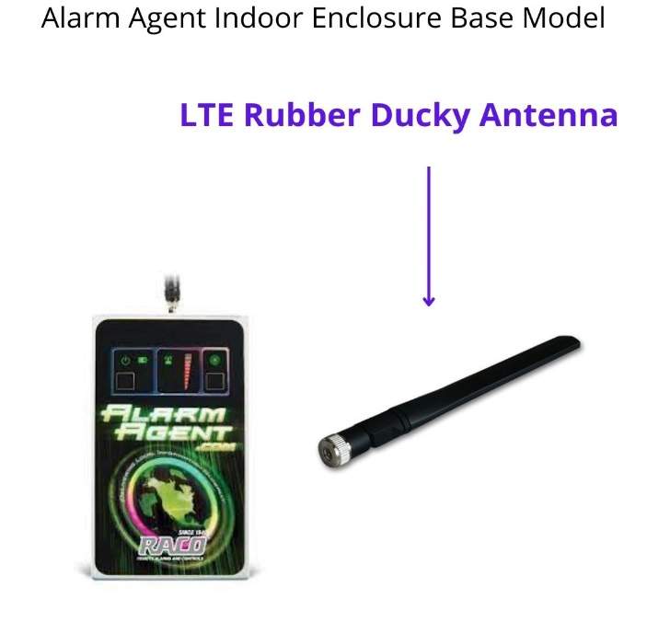

For Alarm Agents that Requires an Extension cable. The extension cables can be 10ft, 20 Feet or 30 feet depending on how high they need the antenna mounted. See below:

